**House Demolitions in Palestine Dataset Analysis**

Yumna Alhyari, 900214295

Department of Math & Actuarial Science, The American University in Cairo

DSCI 1411: Fundamentals of Data Science I

Dr. Ali Hadi

11th December, 2022

**Context and Information**

This dataset helps with understanding how Israel uses specific schemes to target and harm innocent civilians, largely of whom are minors. Analyzing this dataset reveals to the reader that Palestinian house demolition orders are a reoccurring theme that Israel uses to destabilize the lives of harmless people, thus one can argue that such acts should be classified as war crimes. Israel issues house demolition for three primary reasons: on-ground unlawful construction, military reasons, and to punish people. This dataset attempts to provide documentation for Israel’s policies.

The dataset contains information about 270 campaigns of forced house demolitions of Palestinian homes in Palestine from 2004-2021. These demolitions resulted in the destruction of 5498 homes and displaced 25730 people including 5998 minors. The dataset contains the year, number of housing units destroyed, number of displaced residents, number of displaced minors, area of demolition, type of building structure, demolition scope (complete/partial), district, and the reason for demolition (Military purposes, punishment, or on-ground unlawful construction).

Through developing this project, I hope to achieve two things: improve my data analysis skills and deepen my understanding of statistical information through creating graphs and computing numerical analysis, in addition, produce easy-to-read graphs and numerical summaries regarding this issue to be able to spread more awareness as it is not given a sufficient amount of attention in news outlets.

**Questions Covered**

This analysis will aim to answer various questions regarding this topic. These answers allow the reader to understand the extent to which data science can help with visualizing the damage that follows demolition orders. The analysis should equip the reader with answers and consequently create a form of awareness regarding this issue. These questions include but are not limited to:

1. How often does Israel issue demolition orders each year?
2. What are the most targeted areas?
3. How many people are displaced each year?
4. How many minors are displaced each year?
5. What are the most common reasons for demolitions?
6. Are most demolitions partial or complete?
7. What types of structures are mostly demolished?
8. Who carries out most demolitions?

**Data source**

This data set was obtained from the Kaggle website, the specific link for this data set is:

<https://www.kaggle.com/datasets/zusmani/home-demolitions-in-palestine-20042021>

**Data adjustment**

While most of the data were clear and clean, there needed to be some adjustments regarding the demolishment scope variable and the “demolition carried out by” variable, many of the observations lacked an entry- it was not clarified if the demolition was complete or partial or whom it was carried out by- so I had to fill these entries with NA.

**Data Analysis- all years 2004-2021**

|  |  |  |  |  |  |
| --- | --- | --- | --- | --- | --- |
| Six-number summary- Housing Units | | | | | |
| Min. | 1st Qu. | Median | Mean | 3rd Qu. | Max. |
| 77.0 | 146.2 | 223.5 | 305.4 | 311.2 | 1633.0 |

Total number of demolitions: 5498

From the above graph and the six-number summary for housing units demolished, one can observe that the year 2004 was of the highest demolition orders with 1633 demolition orders (which corresponds to the Max value in the table). It is also obvious that the year 2009 was of the least demolition orders as it had 77 demolition orders (which corresponds to the Min value in the table). The difference between the mean and the median is not very big, which means that the outliers did not affect the data that much; however, if the mean was trimmed, a more accurate value that is closer to the median and unaffected by extreme outliers- which are the years 2004 and 2009 as seen in the graph- can be obtained. The 10% trimmed mean = 236.75 and the 20% trimmed mean= 223.25. Both are closer to the median value; this tells us that around 224-237 demolitions are carried out each year and that if this number varies dramatically then the factors on which it depends have changed.

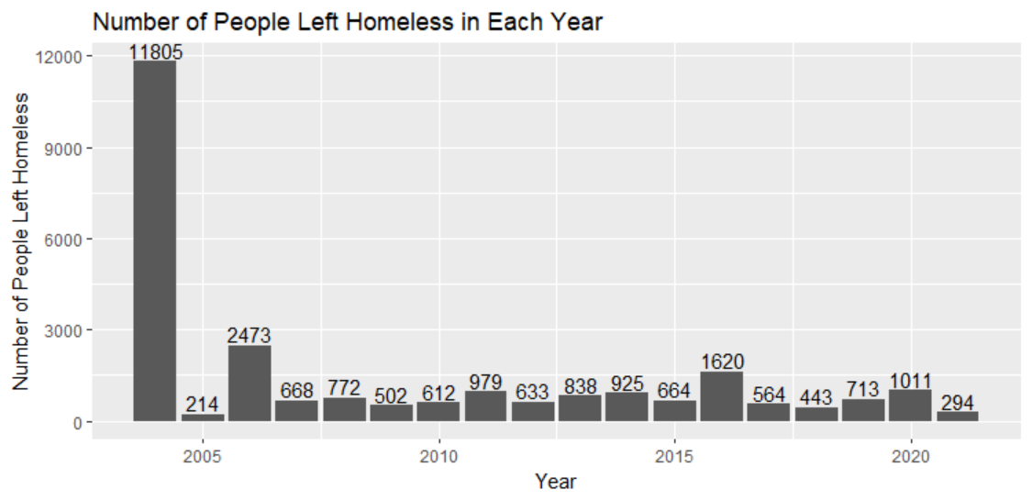

|  |  |  |  |  |  |
| --- | --- | --- | --- | --- | --- |
| Six-number summary- People Left Homeless | | | | | |
| Min. | 1st Qu. | Median | Mean | 3rd Qu. | Max. |
| 214.0 | 576.0 | 690.5 | 1429.4 | 965.5 | 11805.0 |

Total number of people left homeless: 25730

The graph and table tell us that the year 2004 is the year with the largest number of people left homeless with 11805 people. It is expected that the year with the least demolitions would have the least number of people left homeless; however, that is not the case as the year 2005 is the year with the least number of people left homeless with 214. The year 2009 - the year with the least demolitions- has more than double that number! The difference between the mean and the median is rather big, that is because it is heavily affected by the outliers- which are the years 2004,2005,2006,2021,2016 as seen in the graph. The 10% trimmed mean = 856.9375 And the 20% trimmed mean = 740.0833, both values are more accurate and are closer to the value of the median. This tells us that around 691-741 people are left homeless due to the demolition orders issued by Israel and that if this value varies dramatically then I can predict that the factors on which it depends have changed.

|  |  |  |  |  |  |  |
| --- | --- | --- | --- | --- | --- | --- |
| Six-number summary- Minors Left Homeless | | | | | | |
| Min. | 1st Qu. | Median | Mean | 3rd Qu. | Max. | NA’s |
| 78.0 | 196.0 | 340.0 | 334.6 | 451.0 | 809.0 | 1 |

Total number of minors left homeless: 5998

As seen in the graph and table above, the year 2016 is the year with the highest number of minors left homeless, with a maximum of 809. While the year with the least number of minors left homeless is 2005, with a minimum of 78. One might expect that the year with the most demolitions and number of people left homeless would have the highest number of minors left homeless; however, that is not the case here. It is observed that there is one year with no available data – 2017. The mean and the median are close to each other which means that the outliers did not impact the data that much. These values tell us that there are around 335-340 minors left homeless each year due to the demolition orders.

Demolitions in Each Area/District

As the pie chart indicates, most demolitions took place in the region of the West Bank (Excluding East Jerusalem) with a total of 2106 demolitions. The difference between the demolitions carried out in Gaza and East Jerusalem is not that large. Gaza has 174 more demolitions than East Jerusalem with a total number of demolitions of 11783. While this graph gives us an idea about the distribution of demolitions among areas, it does not tell us anything about the distribution of demolitions among districts.

This graph specifies the demolitions in each district rather than the general area. It can be observed that north Gaza has the least number of demolitions whereas East Jerusalem has the largest number of demolitions. It is important to note that East Jerusalem is considered a general area and a district because it holds a lot of significance to the state of Palestine.

This graph gives us an idea of the relationship between the number of demolitions and the number of people left homeless. The number of people left homeless is dependent on the number of demolitions which is the independent variable. It can be observed that with the increase in the number of demolitions, more people are left homeless. To examine the relationship more thoroughly, I calculated the correlation coefficient, in this case, it is equal to 0.9779787 which indicates that the relationship is strongly linear and positive.

This scatterplot visualizes the relationship between the number of demolitions and the number of minors left homeless. The independent variable is the number of demolitions, and the dependent variable is the number of minors left homeless. It is observed that there is no general linear trend between the number of demolitions and the number of minors left homeless. There are also outliers that might affect our results when examining this relationship. Calculating the correlation coefficient gives us “NA” because, as mentioned earlier, the year 2017 has no observation. Therefore, I need to exclude that entry and obtain another value for the correlation coefficient, which is equal to -0.154239 which indicates a weak linear and negative relationship.

**Analysis of Qualitative variables:**

Through analyzing the data, I found that most demolitions are carried out on Residential Structures. There is not sufficient information in the dataset to know by whom these demolitions were mostly carried out as most of the observations for this variable were “NA”. For the demolition scope, most entries were also unavailable therefore it remains unknown whether most demolitions were partial or complete. The most common reason for the demolitions was the pretext of unlawful construction.

**Conclusion**

In conclusion, it is clear that the number of demolitions varies each year depending on multiple factors. The political atmosphere of the state and the occupation is of significant contribution to these numbers, for example, the highest number of demolitions was in 2004 which was during the second Intifada. These demolitions are part of a larger scheme that aims to erase the Palestinian population and their identity in hopes of expanding Israel’s settler colonies within what is internationally recognized as Palestinian territories. It is important to note that most demolitions are carried out in the region around Jerusalem, which can be argued to be the most important city to the Palestinian identity. As one might expect, the relationship between people left homeless and the number of demolitions is a strong positive linear relationship in which the victims of demolition orders are not compensated after having their houses demolished and are left stranded in the streets. There is not a strong linear relationship between the number of houses demolished and the number of minors left homeless. In addition, I found out that residential structures are the most targeted structures, and that there is not sufficient information regarding the demolition scope or the party that carries out most demolitions. The most common reason behind these demolitions was the claim of unlawful construction, it is argued by many Palestinian lawyers that this claim has no legitimate legal grounding; therefore, even if the construction was lawful, then the state of Israel will still find a way to enforce their house demolition orders.